
The Hashemite University, Zarqa, Jordan
Faculty of Prince Al-Hussein Bin Abdallah II for Information Technology
Software Engineering Department

Sky Trip

A project submitted
in partial fulfillment of the requirements for the
B.Sc. Degree in Software Engineering

By:
Ali Rami Ali AL-Aidi | 2330105
Emran AbdAlhameed Hamad Al-Harahsheh | 2240190
Talal Ali Mahmoud Al-Qudah | 2232462
Tasneem Mohammed Nour Al-Hashlamoun | 2241307

Supervised by
Aladdin Hussein Baarah

CERTIFICATE

It is hereby certified that the project titled "Sky Trip”, submitted by the undersigned, in partial fulfillment of the award of the degree of “Bachelor’s in Software Engineering”, embodies original work done by them under my supervision.
All the analysis, design, and system development have been accomplished by the
undersigned. Moreover, this project has not been submitted to any other college or university.

ABSTRACT

The Airline Ticket Reservation System aims to provide a comprehensive digital platform that enables passengers to search for flights, compare prices, book seats, select optional services, and make secure online payments quickly and efficiently. The system simplifies the traditional booking process, which relied heavily on travel agents or airline offices, by offering a user-friendly interface accessible on both web and mobile devices (Android and iOS). Passengers can manage their bookings, receive booking confirmations, upload travel documents, track their tickets, and instantly receive electronic tickets (E-Tickets) via email. On the other hand, the system provides airline companies with tools to manage flights, update schedules, monitor reservations, review passenger information, confirm bookings, and send automated email notifications. The system also includes an Admin panel that allows management of user accounts, roles, and system data. The project is supported by a relational database design to ensure data integrity, along with UML diagrams that illustrate the system architecture and process flows. The expected outcome of this project is an efficient and reliable system that reduces human errors, enhances user experience, and improves the operational efficiency of airline companies.

ACKNOWLEDGEMENTS

We thank everyone who helped us progress in this project, which helped us develop our technical and analytical capabilities.

TABLE OF CONTENTS

CERTIFICATE 2
ABSTRACT
ACKNOWLEDGEMENTS
TABLE OF CONTENTS
ABBREVIATIONS
LIST OF FIGURES
LIST OF TABLES
Chapter 1: Introduction
1.1 Overview
1.2 Project Motivation
1.3 Problem Statement
1.4 Project Aim and Objectives
1.5 Project Scope
1.6 Project Software and Hardware Requirements
1.7 Project Limitations
1.8 Project Expected Output
1.9 Project Schedule
1.10 Project, product, and schedule risks
1.11 Report Organization
Chapter 2: Literature Review
2.1 Introduction
2.2 Existing Systems
2.3 Overall Problems of Existing Systems
2.4 Overall Solution Approach
Chapter 3: Requirement Engineering and Analysis
3.1 Stakeholders
3.2 Use Case Diagram
3.3 Non-Functional User Requirements
3.3 Constraints
Chapter 4: Architecture and Design
4.1 Overview
4.2 Software Architecture
4.3 Software design
4.4 User interface design (prototype)
Chapter 5: Implementation Plan
5.1 Description of Implementation
5.2 Programming language and technology
5.3 part of the implementation if possible 9
6.1 Black-box
6.2 White-box
6.3 Testing automation 40
Chapter 7: Conclusion and Results
7.1 Summary of accomplished project
7.2 Future Work
References

LIST OF FIGURES

Figures 3.1: Use Case Diagram …………………………………… 1
Figures 4.2.1: Component Diagram……………………….……… 1
Figures 4.2.2.1: Sequence Diagram (Client) …………...………… 1
Figures 4.2.2.2: Sequence Diagram (Airline) ………………..…… 1
Figures 4.2.3: Deployment Diagram ……………………………… 1
Figures 4.3.1: Class Diagram …………………………………...… 1
Figures 4.4.1: ER Diagram ………………………………………... 1
Figures 4.4.2: Schema Diagram ………………………………...… 1
Figures 4.5: State Diagram ……………………………………...… 1
Figures 4.6: Interface Prototype ………………………………..… 1

LIST OF TABLES

Table 1.1: Project Schedule …………………………………..…….. 1
Table 3.1: Book Trip ………………………………………….…….. 1
Table 3.2: Make Payment ……………………………..……………..1
Table 3.3: Manage Flight ………………………………………..….. 1
Table 3.4: Book Confirmation ……………………..……………….. 1
Table 3.5: Manage Tickets ………………………………………….. 1
Table 5.1: Programming Language………………………………….. 1
Table 6.1: Book Trip ………………………………………………... 1
Table 6.2: Missing Traveler Data ………………………………….... 1
Table 6.3: Invalid Document Information …………………………... 1
Table 6.4: Successful Payment ……………………………………… 1
Table 6.5: Payment Failed …………………………………………... 1
Table 6.6: Airline System Not Responding …………………………. 1
Table 6.7: Manage Flight …………………………………………… 1
Table 6.8: Manage Tickets ………………………………………….. 1
Chapter 1: Introduction
  - Overview
Booking flight tickets through mobile applications is one of the easiest and fastest
ways to travel today. They allow travelers to search for flights and compare prices within seconds, and provide ease of use that many applications lack.

Users receive their electronic tickets immediately after payment without visiting a travel office. Applications also provide options such as seat selection and extra baggage.

  - Project Motivation
Many other apps suffer from problems such as ease of use and simplicity, which are essential for making the ticket booking process easier and faster, and this is what motivated us to develop this app.

  - Problem Statement
Travelers face difficulties when booking airline tickets through traditional methods, as the process often requires visiting travel agencies or waiting on the phone for long periods. This procedure is time-consuming and limits the ease of comparing prices and available flights. In addition, relying on paper-based processes may lead to data errors and the loss of tickets. The lack of real-time information about offers and availability also makes the process less flexible and convenient. These challenges highlight the need for modern and fast electronic solutions for booking airline tickets; however, such solutions require applications that are faster, more intuitive, and simpler—not like the current applications.

  - Project Aim and Objectives
The “Sky Trip” app primarily aims to simplify the flight booking process by providing a fast, convenient, secure, and user-friendly online solution. The app allows users to search for flights, compare prices, and easily select additional services such as seats and baggage allowances. It also strives to provide a seamless user experience with instant ticket delivery after payment and notifications of special offers and discounts. Ultimately, the app aims to enhance the travel experience and increase customer satisfaction with flight booking services. The system additionally allows users to search for one-way, round-trip, and multi-city flights, enables passenger data entry with document upload (passport/ID), supports optional service selection (meals, baggage, wheelchair assistance, etc.), provides Admin and Employee dashboards for flight and booking management, sends automated email notifications upon booking confirmation or cancellation, and supports seat selection via an

1.5 Project Scope

This will include only:
Key Features:

-Book flights online quickly and securely
-Receive tickets online instantly after payment
-Select seats and add necessary luggage
-Easy and simple user interface for navigation and booking
-User registration, login
-Flight search (one-way, round-trip) with city and date filtering
-Passenger information and document upload
-Optional services selection
-Seat map selection
-Stripe payment integration with polling confirmation
-Admin dashboard: manage flights, bookings, roles
-Employee dashboard: update flights, review and confirm bookings
-Email notifications for confirmation and cancellation
-Mobile app (Flutter) and web frontend
- Electronic ticket generation with QR Code for booking verification.
- Display passenger and booking details within the electronic ticket.

Additional Features (Future Phases):

-Book hotels through the “Sky Trip” app
-Book cars through the “Sky Trip” app
-Google Sign-In integration
-Biometric login
-Loyalty miles full integration

1.6 Project Software and Hardware Requirements
To run the application, users need smartphones that meet specific requirements to ensure smooth performance. For Android devices, the application requires a minimum version of Android 8.0 (Oreo) or later. The device must have a quad-core processor with a speed of at least 1.5 GHz, at least 2 GB of RAM (4 GB recommended for optimal performance), and a screen with a resolution of at least 720 x 1280 pixels (HD) and a size of 5 inches or larger for easy browsing and use. Additionally, the device must have a stable internet connection via Wi-Fi or mobile data (3G minimum, 4G or 5G preferred), along with at least 200 MB of free storage space for installing the application and additional storage space for cached data.
For devices running iOS, the application requires an operating system version of iOS 13.0 or later. The device should be an iPhone 6s or newer, equipped with an Apple A9 processor or better. The application requires a minimum of 2 GB of RAM and at least 200 MB of free storage space for installation, with additional space for cached data. A display resolution of at least 750 × 1334 (Retina) is recommended for a comfortable user experience.
Web requirements: Any modern browser (Chrome, Firefox, Edge, Safari) with an active internet connection is required to run the web version of the application.

1.7 Project Limitations
The application's use is limited to a specific country due to project requirements.
Users need a stable internet connection to access application functions, such as searching for flights, logging into their accounts, and communicating with airline staff via instant messaging. This poses a challenge for individuals in areas with limited connectivity.

  - Project Expected Output
1. Simplified Booking Process: The application will enable users to search for and book flights more efficiently.
2. User-Friendly Interface: A simple design allows users to easily navigate, search for flights, and manage their bookings.
3. Direct Communication Channels: Direct communication between airline staff and customers regarding inquiries related to flights, payments, or booking changes.
4. Filtering and Sorting Capabilities: Advanced filters to refine search results based on user preferences such as ticket price, airline, travel class, and departure time.
5. Booking and Scheduling System: Allows users to select flights, reserve seats, and confirm their travel.
6. Admin and Employee Panels: Full management dashboards with role-based access
7. Electronic Ticket with QR Code:
The system generates an electronic ticket containing passenger information, booking details, and a QR Code for quick verification and access.

  - Project Schedule
Table 1 showcases the milestones and Activities for the project schedule.

Phase | Start | due | status
Planning and research | 1/9/2025 | 30/9/2025 | Completed
Requirement Engineering &  Analysis | 30/9/2025 | 31/10/2025 | Completed
Design and Prototyping | 31/10/2025 | 29/11/2025 | Completed
Implementation (Web + Mobile) | 1/12/2025 | 15/5/2026 | Completed
Testing and QA |  |  | Completed
Final Presentation

Table 1.1: Project Schedule.

  - Project, Product, and Schedule Risks
Failing to adhere to the schedule could result in a poorly functioning application, as critical features may remain incomplete due to insufficient time for development, testing, and debugging. This could lead to usability issues and security vulnerabilities. Moreover, a last-minute rush to meet the deadline often causes stress, reduces productivity, and increases the likelihood of errors. These delays could compromise the overall quality of the project and harm team morale.

  - Report Organization
The rest of the document is organized as follows,

- Chapter 2 will talk about existing systems and how they compare to the SKY TRIP Project.
- Chapter 3 will showcase the functional and non-functional requirements that are necessary for the app.
- Chapter 4 will present the analysis of the requirements from Chapter 3.
- Chapter 5 will talk about system design from the implementation perspective

Chapter 2: Literature Review

2.1 introduction
This chapter examines systems like the SKY TRIP project, providing insights into their features, strengths, and limitations. Through analysis, we identify opportunities for innovation and improvement in the SKY TRIP project. These bookings direct travelers to flight tickets to enhance the experience among users.

2.2.1 Existing Systems
The Royal Jordanian mobile application, launched in January 2015, is an official service provided by the national carrier of Jordan. The app is licensed as part of Royal Jordanian’s operations under the Jordanian civil aviation framework. It offers users a convenient platform to search for and book flights, check flight schedules, monitor flight status, and complete mobile check-in. Additionally, passengers can manage their Royal Plus frequent flyer accounts directly through the app. Among its key features are a user-friendly interface, advanced filters for flight search, real-time notifications about flight updates and promotions, and direct access to customer support. The application simplifies the travel process and enhances the overall passenger experience by making airline services more accessible and efficient.
2.3 Overall Problems of Existing Systems
A. Lack of Local Solutions: Current flight booking systems often face numerous challenges. Many platforms have complex and unintuitive interfaces, making the booking process confusing for some users. Limited payment options can also be difficult for travelers who prefer digital wallets or local payment methods. Technical issues, such as slow loading times or system errors, can disrupt the booking process, especially during peak travel seasons. Furthermore, some systems lack effective customer support channels, making it difficult for users to resolve issues quickly. Price fluctuations and hidden fees are also common problems, leading to customer dissatisfaction. Finally, language barriers and a lack of accessibility features can prevent certain groups of travelers from using the platforms effectively.

B. Accessibility Barriers: Flight booking systems face several accessibility barriers that limit their usability for all travelers. A major issue is the lack of multilingual support, making it difficult for non-native speakers to use the platforms. The limited availability of accessibility features, such as screen reader compatibility or text-to-speech functionality, poses challenges for visually impaired individuals. In many areas, users experience poor internet connectivity, restricting their ability to book or manage flights online. Furthermore, some systems are not optimized for mobile devices, making it difficult for users without computers. Complex payment processes and the lack of local payment options also present barriers for many travelers. These issues reduce service inclusiveness and make the booking process less convenient for a wide range of users.
C. High Costs: The high cost of airfare is one of the biggest challenges in booking flights. Prices often fluctuate due to factors such as demand, seasonality, and limited seat availability, which can make travel prohibitively expensive for many. Additional hidden fees, such as service charges, baggage fees, and seat selection fees, also contribute to the overall cost. These high costs not only reduce customer satisfaction but also limit the ability of budget travelers to fly.

D. Trust and Transparency: Trust and transparency are among the most important considerations in airline ticketing systems. Many users experience uncertainty regarding ticket prices, surcharges, and refund policies, which can lead to frustration and distrust. Some platforms do not clearly display cancellation rules, baggage policies, or hidden fees, making it difficult for travelers to make informed decisions. A lack of reliable reviews or documented information about airlines and services also reduces user confidence. Building transparent systems with clear pricing, policies, and readily available support is essential for fostering trust and ensuring a positive booking experience.

E. Lack of Awareness: A common challenge in booking airline tickets is the lack of awareness among travelers regarding available services, promotions, and booking procedures. Many users are unfamiliar with online booking platforms, special offers, or loyalty programs, which can lead to missed opportunities and increased travel costs. Inadequate guidance on using systems effectively or understanding pricing rules often results in booking errors, cancellations, or additional charges. Raising user awareness through clear instructions, educational programs, and informational notices is essential to help travelers make informed decisions and improve the overall booking experience.

2.4 Overall Solution Approach
The Sky Trip app directly addresses these issues by providing a platform specifically designed for the Jordanian market. The proposed solution approach includes the following:

A. Simplified User Interface
Designing a clear and simple interface that enables users to quickly search for flights and book tickets, focusing on essential elements to avoid confusion and clutter, and making navigation between app or website pages easy and intuitive.

B. Providing Diverse Payment Options
Including local and international payment methods, such as credit cards and digital wallets, enabling users to easily choose the most suitable payment option, and reducing problems caused by limited or unsupported payment methods.

C. Enhancing Transparency and Trust
Clearly displaying all fees and costs before completing a booking, explaining cancellation and refund policies in detail, and providing reliable reviews and verified information about airlines and services.

D. Improving Accessibility and Device Compatibility
Ensuring the app functions smoothly on smartphones, tablets, and desktop computers. Offering a lightweight version that loads quickly, even with a weak internet connection.

E. Increase awareness and guidance
Send notifications and alerts about available offers and services.

Chapter 3: Requirement Engineering

3.1 Overview
This chapter introduces the system's stakeholders and covers all functional aspects, including a detailed description of the system and all its features. It also addresses essential non-functional system requirements, such as performance, ease of maintenance, and security.

3.2 Stakeholders

1. End Users
Individuals and small businesses are seeking flight booking services to meet their various travel needs. Small business owners who need to book flights for business trips, meetings, or corporate travel arrangements.

2. Airline Staff
Airline staff are responsible for managing flight schedules by adding, updating, or canceling flights as needed. They also monitor bookings to ensure seat availability, provide customer support to assist passengers with inquiries or issues, and handle booking processing smoothly. Additionally, staff send the customer's tickets after booking confirmation to ensure a seamless travel experience.

3. Application Administrators
The airline's system administrator is responsible for managing user accounts and roles, ensuring that both passengers and staff have secure access with the appropriate permissions. The administrator also controls system settings and security, implementing updates, encryption, and policies to protect data and prevent unauthorized access. Additionally, they safeguard the database by maintaining its integrity, creating regular backups, and ensuring its recovery in case of system failures. They continuously monitor system performance, address technical issues, and guarantee the smooth and reliable operation of the airline's booking platform.

4. Development Team
This team includes project managers, UI/UX designers, front-end and back-end developers, and quality assurance specialists who design, implement, and maintain the platform.

3.2 Use Case Diagram
- Unified Use Case Scenario
When the Client accesses the system, the first step is to log in. During this process, the system must Validate Credentials, and if the client forgets the password, they may use the Forgot Password option. After a successful login, the client can proceed to book a Trip.
To book a trip, the client provides Trip Information (Info Trip), which includes selecting a Trip (Select Trip). The client may choose between One Way, Round Trip, or Multi-City, and then select a Date. Next, the client enters Traveler Data, which includes Personal Information (Person Info) such as name, age, and contact details, and Document Information (Document Info) such as a passport or ID card. The client can also choose additional services by using Select Services (e.g., meals, seat selection).
After completing the information, the client proceeds to Pay for the Trip (Pay Trip). Once the payment is processed, the system enables the client to connect with the airline through either Phone or Email to manage or confirm their booking.
On the airline’s side, represented by the Actor, the system provides functionalities such as Book Confirmation, Manage Flight (including Add Flight, Edit Flight, or Cancel Flight), and Manage Tickets (with options to Cancel Ticket or Modify Ticket). This ensures smooth interaction between the client and the airline, covering all essential aspects from login to booking, payment, and post-booking management.
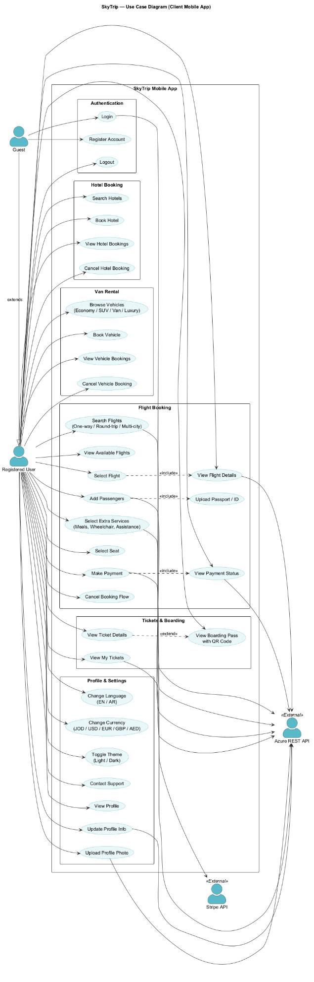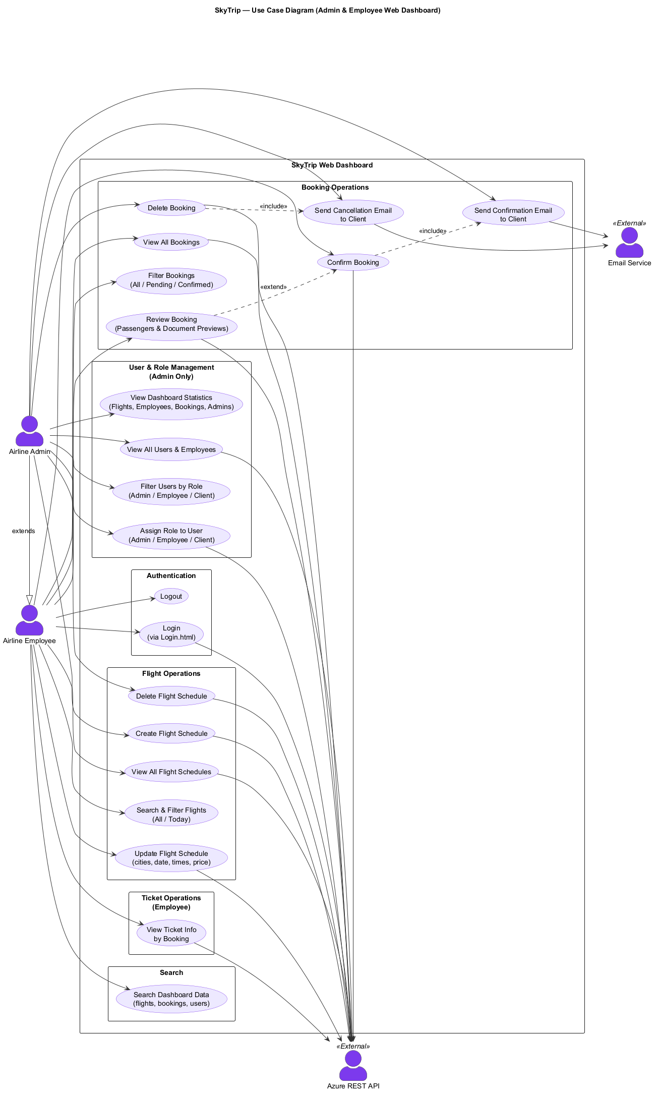
Figures 3.1: Use Case Diagram

3.2.1 Flow of Data
Use Case Name | Book Trip
Actor | Client
Preconditions | - The client must be registered and logged into the system.  - A stable internet/network connection must be available to communicate with the airline.  - A valid payment method (e.g., credit card) must be available.
Basic Flow | - The Client selects Book Trip.  - The system displays trip options: One Way / Round Trip / Multi-City.  - The client selects Date(s) for the trip.  - The client enters Traveler Data, including:  - Personal Info (name, birth date, gender).  - Document Info (passport or ID number).  - The client selects Passenger Class (Economy or Business).  - The client chooses optional additional services (Select Services) such as Meal or Moving Corset.  - The client proceeds with payment (Pay Trip).  - The system connects with the airline (Connect) to process the booking.  - The system generates a Booking Confirmation
Alternative Flow | - Optional Services:  - The client may skip additional services and proceed with only passenger class selection.  - Payment Failure:  - If the payment fails, the system displays an error and prompts the client to retry or use another payment method.  - Airline Connection Failure:  - If the system cannot connect to the airline, the booking cannot be completed. The client is notified and advised to try again later.
Postconditions | - Success:  - The booking is successfully stored in the system.  - The client receives an e-ticket and a booking reference number.  - Failure:  - No booking is created.  - The client is notified of the reason (payment failure, connection issue, etc.).

Table 3.1: Book Trip

Use Case Name | Make Payment
Actor | Client
Preconditions | - The client must have selected a trip (Book Trip in progress).  - The client must be logged into the system.  - A valid payment method (credit/debit card, e-wallet, etc.) is available.  - The booking details (fare, taxes, services) are already calculated.
Basic Flow | - The Client chooses to proceed with Payment after trip selection.  - The system displays the total fare (including taxes and additional services).  - The client selects a payment method (e.g., credit card, debit card, PayPal, etc.).  - The client provides payment details (card number, expiry date, CVV, etc.).  - The system validates the entered payment details.  - The payment request is sent to the payment gateway/bank.  - The payment gateway returns a confirmation of approval.  - The system confirms that the payment was successful.  - The booking process continues to Book Confirmation
Alternative Flow | - Invalid Payment Details:  - If the entered card details are invalid, the system notifies the client and prompts for correction.  - Insufficient Funds:  - If the bank declines the transaction, the system notifies the client and allows them to retry with another payment method.  - Payment Gateway Timeout/Failure:  - If the payment gateway is unavailable, the system informs the client and requests that to try again later
Postconditions | - Success: The payment was successfully processed. The transaction record is stored in the system. The customer will be redirected to the booking confirmation.  - Failure: The booking was not confirmed. The customer will be notified of the failure reason (invalid details, insufficient balance, or portal error).

Table 3.2: Make Payment

Use Case Name | Manage Flight
Actor | Airline
Preconditions | - The airline staff must be logged into the system with valid credentials.  - The airline must have authorization to update flight details.  - Flight data (scheduled flights) must already exist in the system.
Basic Flow | - The Airline selects Manage Flight from the system menu.  - The system displays a list of scheduled flights.  - The airline can perform one or more of the following actions:  - Update Flight Status (On Time, Delayed, Cancelled).  - Modify Flight Details (date, time, gate, etc.).  - Enter Flight Number for new or updated schedules.  - The system validates the changes.  - The updated flight information is stored in the system.  - The system automatically notifies clients (via email, SMS, or app notification) about changes
Alternative Flow | - Invalid Flight Number:  - If the flight number does not exist in the system, an error is shown, and the airline must re-enter the correct number.  - Unauthorized Action:  - If the airline staff does not have the correct permissions (e.g., attempting to add a new flight), the system denies access.  - System Error:  - If the update cannot be saved due to technical issues, the system shows an error and prompts to try again later
Postconditions | - Success:  - Flight information is successfully updated.  - Clients receive updated flight status/details.  - Failure:  - No changes are saved.  - The airline is notified of the failure reason (invalid data, system error, or insufficient permissions)

Table 3.3: Manage Flight

Use Case Name | Book Confirmation
Actor | Airline
Preconditions | - The client must have completed the Payment step successfully.  - The booking request must already exist in the system.  - The airline system must be available and connected
Basic Flow | - The Airline receives a booking request from the system after successful payment.  - The airline system validates the booking details (traveler data, flight availability, seat class).  - The airline confirms the booking and generates a PNR (Passenger Name Record) or booking reference number.  - The system stores the confirmation details.  - The system sends a confirmation message to the client (via email/SMS/app), including:  - Booking reference number  - Flight details  - Traveler details  - Ticket information (e-ticket)  - The system generates an electronic ticket containing passenger information, booking details, and a unique QR Code for ticket verification and quick access.
Alternative Flow | - Seat Unavailable:  - If the selected seat/class is unavailable, the airline rejects the booking, and the system prompts the client to reselect.  - Airline System Error:  - If the airline system is down/unreachable, the booking remains pending, and the client is notified of the delay.  - Data Validation Failure:  - If traveler or document information is invalid, the airline rejects the confirmation request, and the client must correct the data
Postconditions | - Success:  - The booking is confirmed in the airline system.  - The client receives a valid e-ticket and booking reference.  - Failure:  - The booking is not confirmed.  - No ticket is issued.  - The client is notified of the failure reason (unavailable seat, system error, invalid data).

Table 3.4: Book Confirmation

Use Case Name | Manage Tickets
Actor | Airline
Preconditions | - The airline staff must be logged into the system with valid credentials.  - The booking must already exist in the system.
Basic Flow | - The Airline selects Manage Tickets from the system menu.  - The system displays a list of existing bookings/tickets.  - The airline can perform one or more of the following actions:  - Cancel Ticket (upon client’s request).  - Modify Ticket (update traveler info, change flight date/time, change class).  - Reissue the Ticket after modification or correction.  - The system validates the requested action.  - The updated ticket information is stored in the system.  - The system notifies the client of the changes (via email, SMS, or app notification).
Alternative Flow | - Invalid Ticket Number:  - If the entered ticket number does not exist, the system displays an error message.  - Unauthorized Modification:  - If the airline staff tries to perform actions outside their authority (e.g., issuing new tickets), the system denies access.  - System Error:  - If the update cannot be processed due to technical issues, the system shows an error and requests to try again later
Postconditions | - Success:  - Tickets are successfully cancelled, modified, or reissued.  - The client receives updated ticket details.  - Failure:  - No changes are applied.  - The airline staff is notified of the reason for failure (invalid ticket, system error, lack of authorization)

Table 3.5: Manage Tickets

3.3 Non-Functional Requirements

Performance Requirements:

1. The system must support at least 100 concurrent users without any performance degradation.

2. The response time for user actions, such as booking a flight, must not exceed 15 minutes.

Usability Requirements:

1. The user interface must be user-friendly and adhere to modern UI and UX design principles, ensuring easy navigation for all types of users.

2. The platform must support multiple languages, such as Arabic and English, to meet the needs of a diverse audience.

Reliability Requirements:

1. The system must maintain 99.9% uptime, especially during peak usage times (such as flight bookings).

2. A robust error-handling mechanism must provide helpful feedback to users in case of failures.

Security Requirements:

1. All user and airline data must be encrypted during transmission (e.g., using HTTPS) and during storage.

Maintenance Requirements:
1. The code must adhere to clean programming standards and include appropriate documentation for future updates.
2. System logs must record all changes and errors to facilitate debugging.

Accessibility Requirements:
1- The platform must comply with WCAG 2.1 guidelines to ensure
accessibility for users with disabilities.

Portability Requirements:
  - The platform must function seamlessly across various devices (desktops, tablets, and smartphones) and multiple web browsers.

Legal and compliance requirements:
1- The platform must comply with local data protection regulations, such as the General Data Protection Regulation (if applicable) or local privacy laws.

3.4 Constraints
1- Functional Constraints

A. Baggage Constraints
• Passengers cannot carry more than the allowed weight/size according to ticket type and destination.
• Hand baggage (carry-on) must not exceed 7 kg and must fit specific dimensions.
• Sharp objects, explosives, and large quantities of liquids are prohibited in cabin baggage.
• Excess baggage requires additional fees or may not be permitted with certain ticket classes.

B. Booking & Payment Constraints
• Full payment must be completed at the time of online booking.
• Credit card payments require additional verification (Secure Code/3D Secure).
• A booking is not confirmed if payment is not completed within the specified deadline.
• Refunds are processed only through the original payment method.

C. Refund & Cancellation Constraints
• Conditions vary by ticket type (refundable vs. non-refundable).
• Service fees are generally non-refundable.
• Refund requests must be submitted by the original booking holder with ID and receipt.
• Some tickets cannot be canceled after the flight departure time.

D. Reservation Constraints
• Fare prices can be held temporarily until midnight (Amman local time) if the trip is more than one week away.
• For North America: passengers may cancel bookings within 24 hours of purchase without penalty, provided the departure is at least 7 days away.

E. Excess Baggage Constraints
• Baggage exceeding the weight/size limit is subject to additional charges.
• Some ticket types (e.g., infant tickets) are not eligible for excess baggage purchase.
• Excess baggage purchase is not valid on codeshare flights.

F. Travel Document Constraints
• Passengers must hold valid passports and required visas before the flight.
• The airline is not responsible for passengers who fail to present valid travel documents and may deny boarding

2. Technical Constraints

1. The system must be web-based and support smartphones (iOS/Android).
2. All communications must use HTTPS (SSL/TLS).
3. Integration with electronic payment systems (Visa, MasterCard, PayPal).
4. Flight search response time must be less than 3 seconds.
5. The system must support at least 10,000 concurrent users.
4. User Experience Constraints:
1- The app must be simple and easy to use, with an average registration time of less than 3 minutes.
2- The app design must ensure responsiveness and proper functionality across all screen sizes.
3- Instant notifications will be sent to users when a ticket is booked after the payment process.

Chapter 4: Architecture and Design

4.1 overview
In this chapter, we will present the analysis of requirements from Chapter 3. This section aims to create a shared understanding of the project's goals and deliver a software solution that fulfills those needs effectively and examine the overall system design, logical Database design, and showcase a simple prototype of the Sky Trips app.

4.2 Software Architecture:
Require UML diagrams using a tool supporting the UML specification.

4.2.1 Component Diagram:

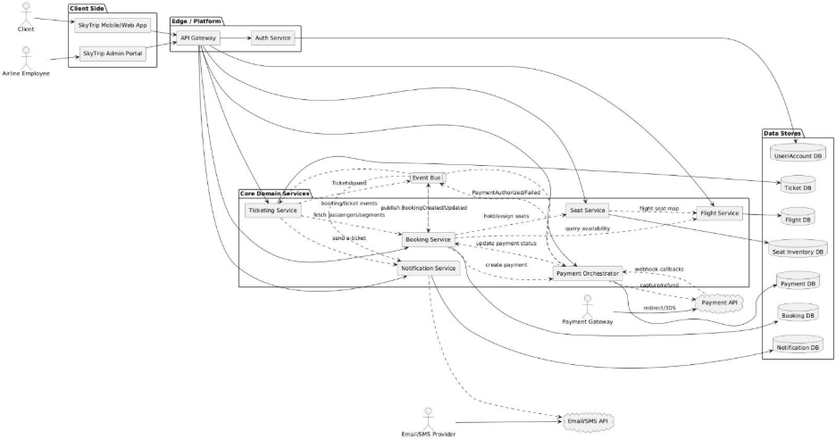

Figures 4.2.1: Component Diagram

4.2.2.1 Sequence Diagram (Login):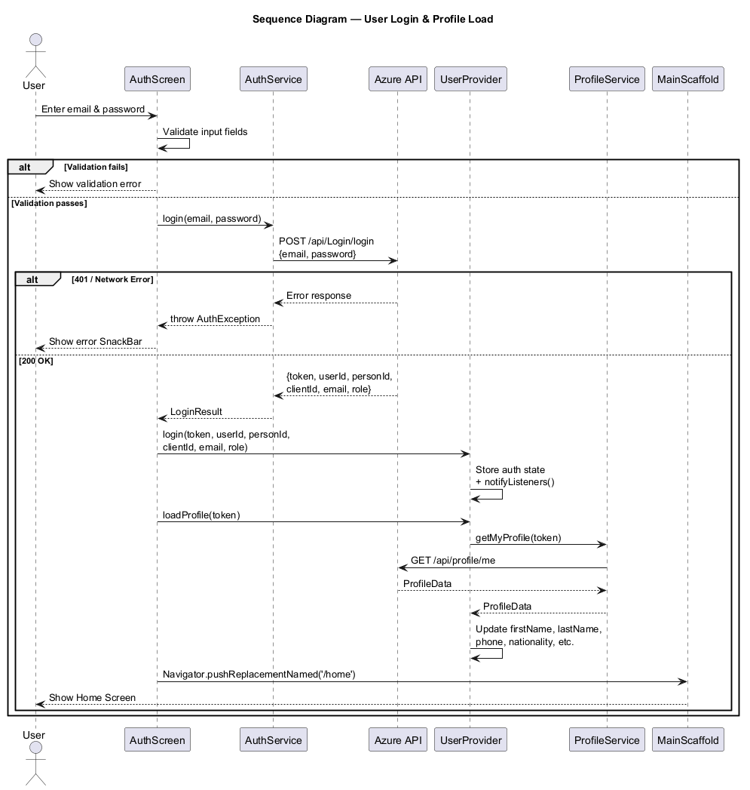

Figures 4.2.2.1: Sequence Diagram (login)

4.2.2.2 Sequence Diagram (Flight booking):

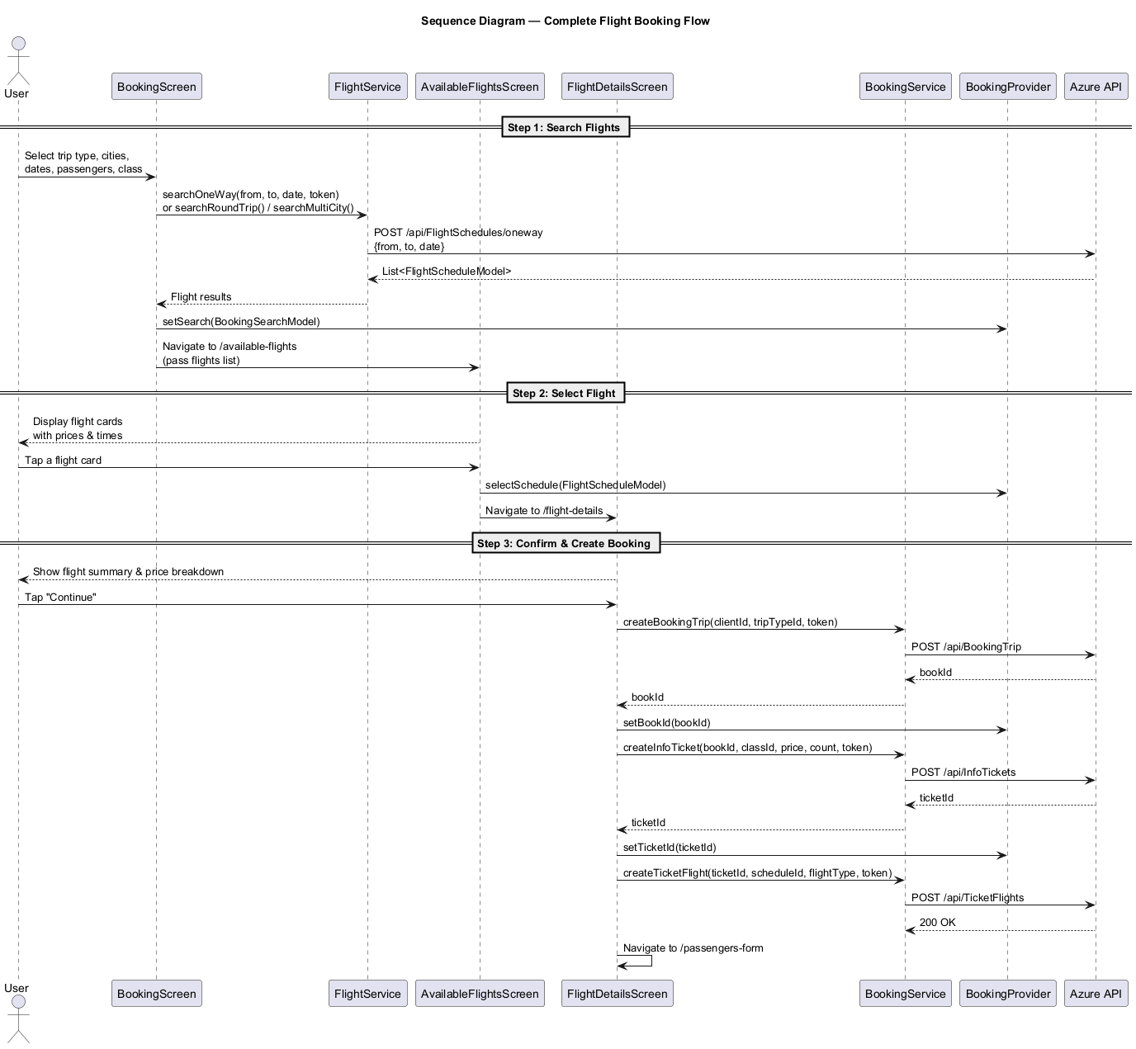

Figures 4.2.2.2: Sequence Diagram (Flight Booking)

4.2.2.3 Sequence Diagram (Admin Dashboard):
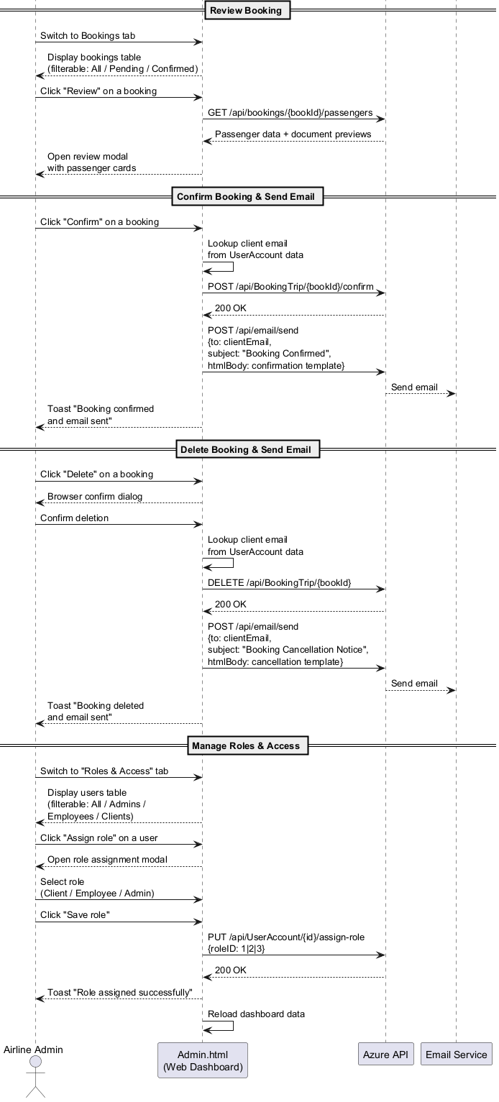
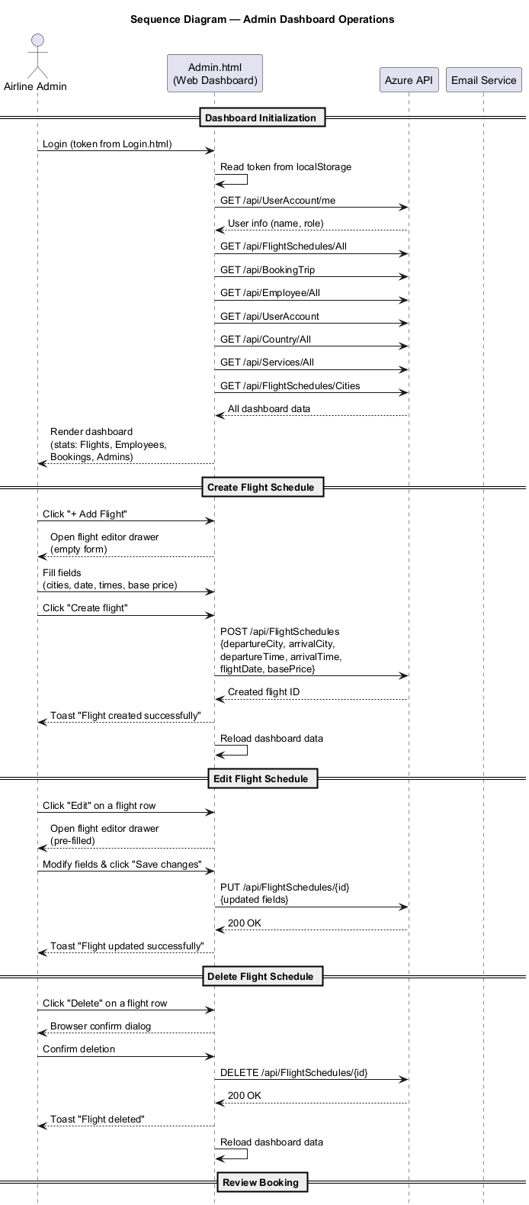
4.2.2.4 Sequence Diagram (payment gateway):

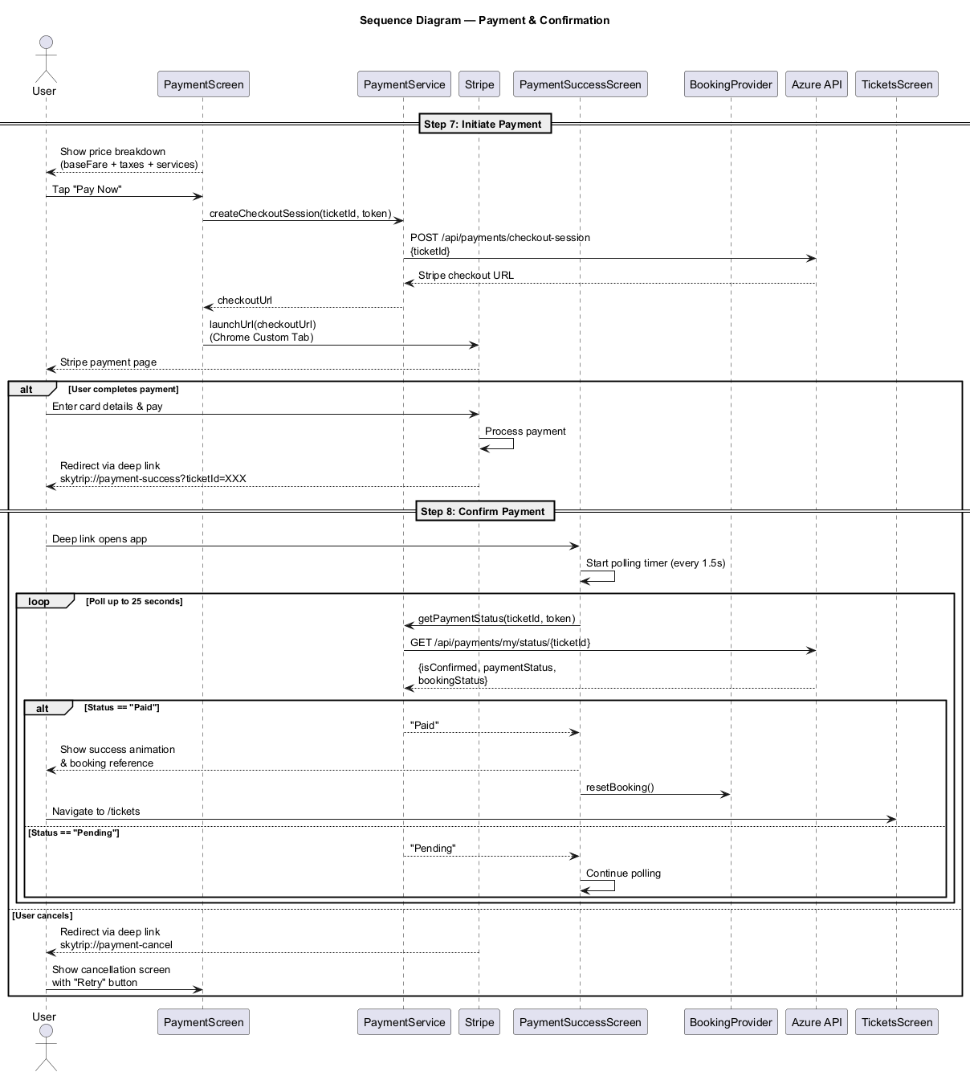

4.2.3 Deployment Diagram:

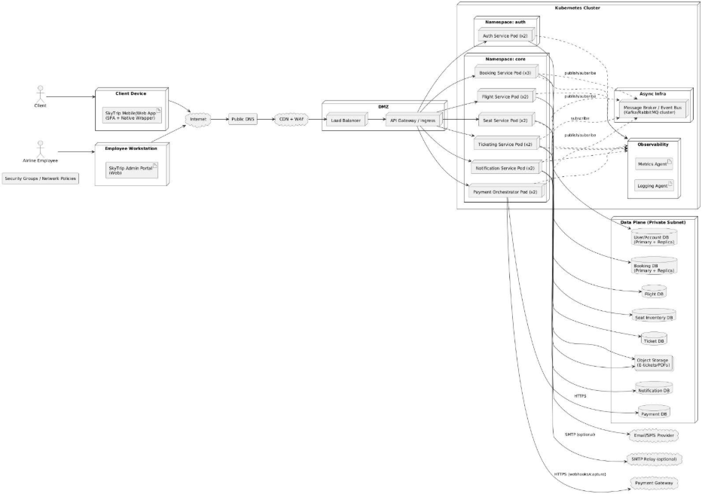

Figures 4.2.3: Deployment Diagram

4.3 Software Design:

4.3.1 Class Diagram:
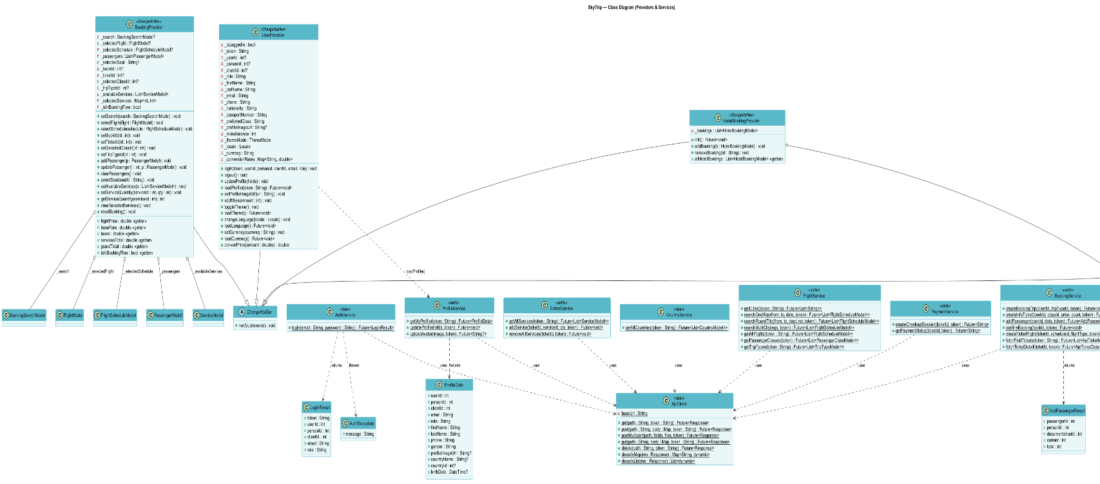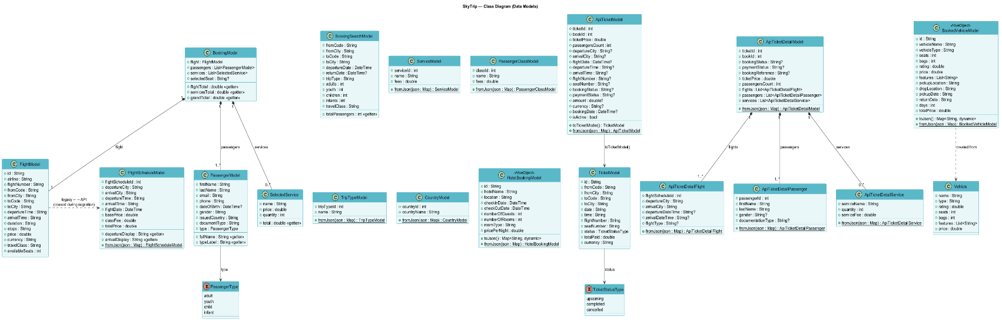
(ProvidersServices) (Models)

Figures 4.3.1: Class Diagram

.4.1 ER Diagram:

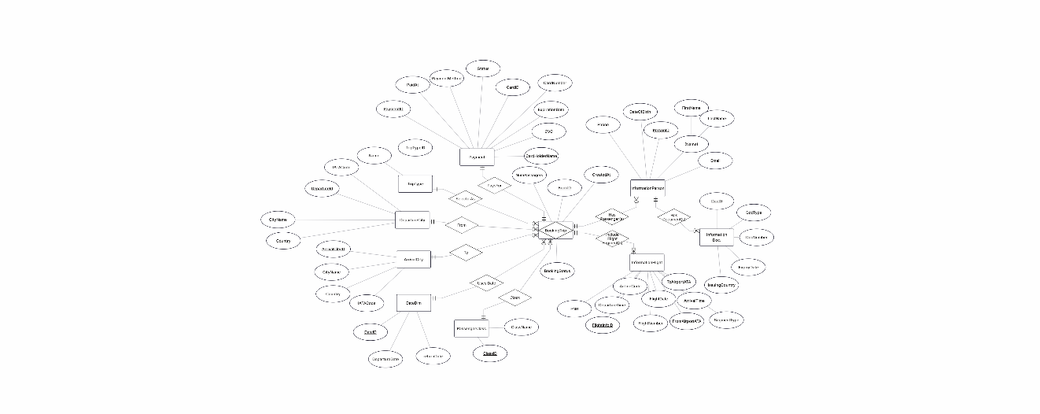

Figures 4.4.1: ER Diagram

4.4.2 Schema Diagram:

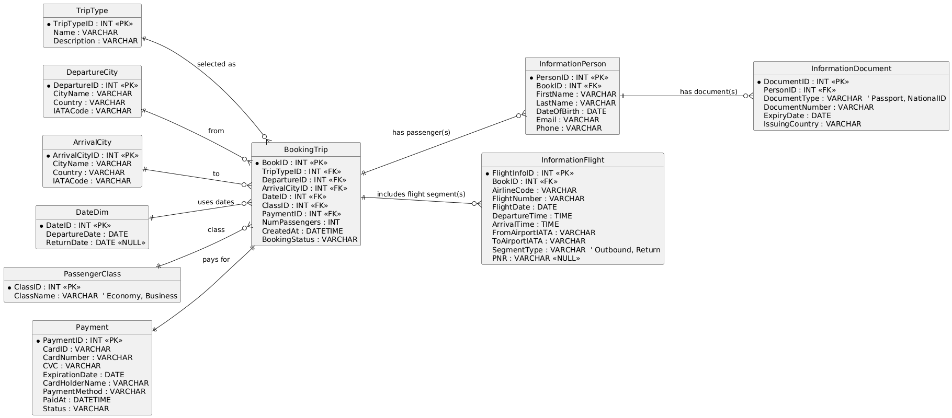
Figures 4.4.2: Schema Diagram

4.5 State Diagram:
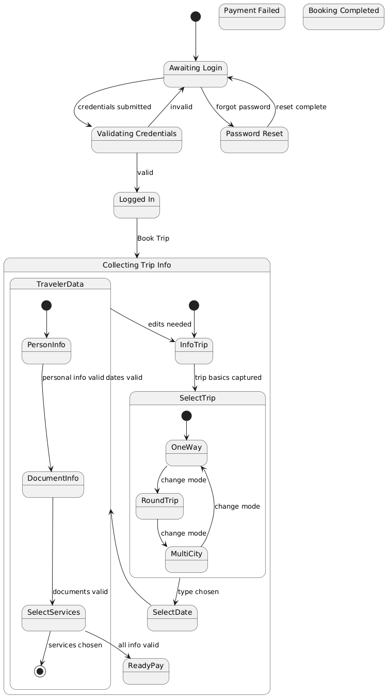

Figures 4.5: State Diagram

4.6 Interface Prototype (Figma):

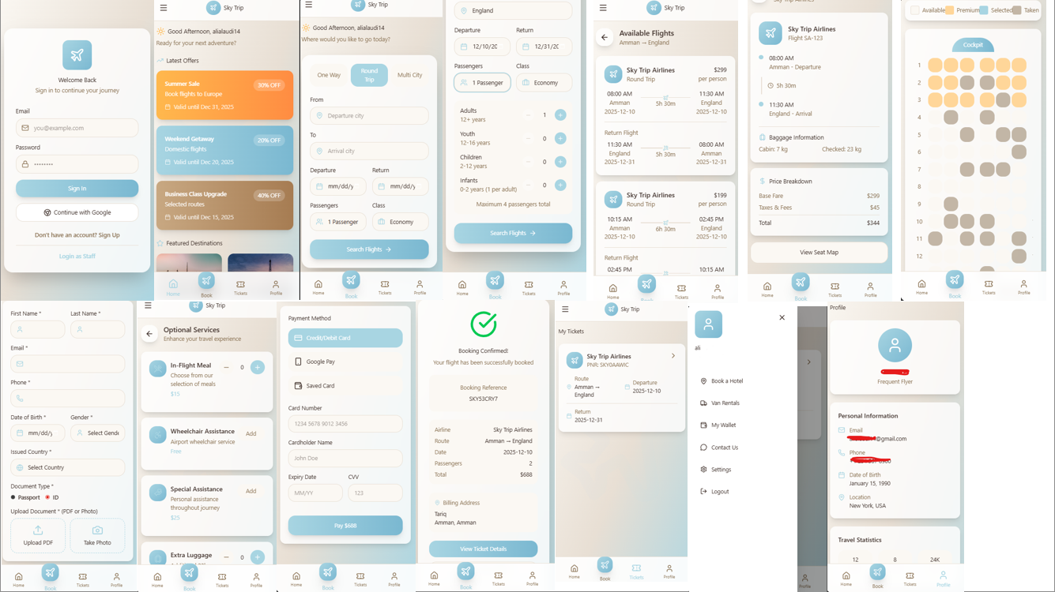

Figures 4.6: Interface Prototype

Chapter 5: Implementation Plan

5.1 Description of Implementation
This section describes the implementation approach of the proposed information system. The solution is implemented using a 3-Tier Architecture, which separates the application into independent layers: Presentation Layer, Business Logic Layer, and Data Access Layer. This architecture provides modularity, scalability, and maintains separation of concerns.
The core backend is developed using ASP.NET Core and exposes a RESTful API that communicates with the Flutter front-end application. The API handles all business operations and interacts with the SQL Server database through a Data Access Layer using Entity Framework Core.

The implementation plan includes the deployment, installation, configuration, and transition into a fully operational system. The major implementation tasks include:
- Designing and creating the SQL Server database schema, including tables, relationships, and stored procedures.
- Developing the API endpoints for core features (authentication, CRUD operations, data retrieval, etc.).
- Implementing business logic services to validate data, enforce rules, and process requests.
- Integrating the Flutter front-end with the API using HTTP/JSON communication.
- Conducting testing (unit, integration, API tests) and fixing issues before deployment.
- Deploying the API to a hosting environment (e.g., IIS, Azure, or Docker container).
- Deploying the database on the SQL Server instance and performing required migrations.
- Developing the web frontend pages using HTML, CSS, and JavaScript to communicate with the same API endpoints.
- Integrating Stripe payment gateway for secure online payment processing with session creation and status polling.

Resources Required
- Hardware: Development computers, server machine, or cloud hosting for deployment.
- Software:
  - SQL Server Database Engine
  - Visual Studio 22
  - Postman for API testing
  - GitHub for version control
  - .NET Core SDK
  - Flutter SDK
  - VS Code (for web frontend development)
  - Stripe Account (payment processing)

- Personnel:
  - Backend Developer (.NET Core)
  - Front-end Developer (Flutter)
  - Database Administrator
  - QA/Tester
  - Front-end Web Developer (HTML/CSS/JS)

The implementation requires standard development tools only, with no special site-specific requirements except access to the SQL Server instance and deployment environment configuration.

5.2 Programming Language and Technology
The implementation uses a combination of modern programming languages and technologies to build a scalable, modular, and maintainable information system.
Programming Languages

Component | Technology | Type
API Backend | C# (.NET Core) | Programming Language
Front-end Mobile | Dart (Flutter) | Programming Language
Front-end Web | HTML / CSS / JavaScript | Web Technologies
Database | T-SQL (SQL Server) | Query Language
Payment | Stripe API | Third-party Service
State Management | Provider (Flutter) | Mobile Architecture Pattern
Testing Tools | JSON/Postman | Data Format

Table 5.1: Programming Language

Software and Tools
- Microsoft SQL Server (Database) – Commercial
- ASP.NET Core (Backend Framework) – Open Source
- Flutter SDK (Front-end Framework) – Open Source
- Visual Studio – Commercial
- Git & GitHub – Open Source / Cloud Platform
- Postman – Free testing tool

Implementation Tools
- Entity Framework Core Migrations for database schema updates
- Swagger UI for documenting and testing API endpoints
- AutoMapper (optional) for mapping DTOs and Entities

5.3 Version Control
All source code, documentation, and project assets are tracked using Git as the version control system. A GitHub repository is created for collaboration, branch management, pull requests, and issue tracking.
Each team member has an individual GitHub account, and commits are attributed using their identity. Commitment messages follow a clear naming convention describing the purpose of each change.
Branches used:
- main (stable production code)
- dev (active development)
- feature/* (new features)
- fix/* (bug fixes)
Repository Example (replace with your link):
GitHub Repository Link:
https://github.com/Retr0-9/sky-trip

Chapter 6: Testing Plan

6.1 Black-box Testing

Test Case 1: Book Trip (Valid Booking)
Test ID | TC- BT- 01
Description | Verify successful trip booking with valid trip details and valid traveler data
Input | Trip Type = “One Way”, Destination = “Amman → Dubai”, Date = "2025-02-10", Traveler Info (Valid), Document Info (Valid)
Expected Output | System proceeds to the payment page.

Table 6.1: Book Trip
Test Case 2: Missing Traveler Data
Test ID | TC-TR-02
Description | Verify system behavior when required traveler data fields are missing.
Input | Name = “ ” (empty), Passport Number = "A12345", DOB = "1999-05-05"
Expected Output | Error message: “Required fields are missing.” Traveler cannot proceed.

Table 6.2: Missing Traveler Data

Test Case 3: Invalid Document Information
Test ID | TC-DOC-03
Description | Verify system response when the document has expired.
Input | Passport Expiry Date = “2020-01-01”
Expected Output | System displays: “Document has expired.” The user must correct the data

Table 6.3: Invalid Document Information

Test Case 4: Successful Payment
Test ID | TC- BAY-04
Description | Verify successful payment using a valid credit card
Input | Card Number = “4111 1111 1111 1111”, CVV = 123, Balance = Sufficient
Expected Output | Payment approved → Redirect to Booking Confirmation page.

Table 6.4: Successful Payment

Test Case 5: Payment Failed (Insufficient Funds)
Test ID | TC- BAY- 05
Description | Verify payment failure when a user has an insufficient balance.
Input | Card Number = "4111 1111 1111 1111", CVV = 123, Balance = Insufficient
Expected Output | “Payment declined — insufficient funds.” Users must retry.

Table 6.5: Payment Failed

Test Case 6: Airline System Not Responding
Test ID | TC- AIR- 06
Description | Verify system behavior when the airline server is unreachable.
Input | Valid booking request + Airline system offline
Expected Output | “Unable to connect to airlines. Please try again later.” The booking is not completed.
Table 6.6: Airline System Not Responding

Test Case 7: Manage Flight (Update Flight Successfully)
Test ID | TC- MF- 06
Description | Verify that airline staff can update an existing flight.
Input | Flight No: "RJ402", Status = "Delayed"
Expected Output | “Flight updated successfully.” Customers receive notifications.

Table 6.7: Manage Flight

Test Case 8: Manage Tickets (Invalid Ticket Number)
Test ID | TC- TK- 08
Description | Verify system response when modifying a non-existing ticket.
Input | Ticket Number = “000000”
Expected Output | “Ticket not found.” No changes applied.

Table 6.8: Manage Tickets

Test Case 9: Login Successfully
Test ID | TC-LG-09
Description | Verify successful login with valid credentials.
Input | Email = "user@test.com  Password = "Test123"
Expected Output | The user is authenticated successfully and redirected to the Home Page.

Table 6.9: Login Successfully

Test Case 10: Invalid Login Credentials
Test ID | TC-LG-10
Description | Verify system behavior when invalid login credentials are entered.
Input | Email = "user@test.com  Password = "WrongPassword"
Expected Output | Error message: "Invalid email or password."  User remains on Login Page.

Table 6.10: Invalid Login Credentials

Test Case 11: Forgot Password
Test ID | Test ID TC-FP-11
Description | Verify successful password reset request.
Input | Registered Email Address
Expected Output | Password reset link is sent to the user's email.

Table 6.11: Forgot Password

Test Case 12: Search Flight Successfully
Test ID | Test ID TC-SF-12
Description | Verify successful flight search using valid trip details.
Input | From = "Amman"  To = "Dubai"  Date = "2026-06-20"  Trip Type = "One Way"
Expected Output | System displays available flights matching the search criteria.

Table 6.12: Search Flight Successfully

Test Case 13: Same Departure and Arrival City
Test ID | Test ID TC-SF-13
Description | Verify system validation when departure and arrival cities are the same.
Input | From = "Amman"  To = "Amman"
Expected Output | Error message:  "Departure and destination cities cannot be the same."

Table 6.13: Same Departure and Arrival City

Test Case 14: Missing Departure Date
Test ID | Test ID TC-SF-14
Description | Verify system behavior when departure date is not selected.
Input | From = "Amman"  To = "Dubai"  Date = Empty
Expected Output | Error message:  "Please select a departure date."

Table 6.14: Missing Departure Date

Test Case 15: Multi-City Booking
Test ID | Test ID TC-BT-15
Description | Verify successful booking using the Multi-City option.
Input | Trip Type = "Multi-City"  Route 1 = Amman → Dubai  Route 2 = Dubai → London
Expected Output | System creates a valid multi-city itinerary and proceeds to payment.

Table 6.15: Multi-City Booking

Test Case 16: QR Code Generation
Test ID | Test ID TC-TK-16
Description | Verify QR Code generation after successful booking confirmation.
Input | Confirmed Booking
Expected Output | System generates a valid QR Code and attaches it to the electronic ticket.

Table 6.16: QR Code Generation

6.2 White-box Testing
White-box testing focuses on internal logic, code structure, and flow.
Techniques Used
- Statement Coverage
Ensure every line in the login, booking, date picker, and payment modules is executed at least once.
- Branch Coverage
Test all conditions:
  - Valid vs invalid login
  - Payment success vs failure
  - Seat selection available vs unavailable
- Path Coverage
Verify all possible flows in booking (search → details → seat map → payment → confirmation).
- Unit Testing
Each function is tested independently (e.g., form validation, API parsing).
Sample White-Box Test Cases
TestID | Code Area | Description | Expected Output
WC-01 | LoginService.validate() | Test function with valid & invalid inputs to cover all branches | Returns true/false correctly
WC-02 | SearchController.filterFlights() | Verify handling of empty lists, multiple filters, and sorting | All branches executed
WC-03 | PaymentService.processPayment() | Simulate success, failure, and timeout | All branches executed
WC-04 | SeatMapController.assignSeat() | Path testing with seat availability logic | Assigns a seat or throws an error

6.3 Testing automation
This section includes tools, approaches, and test cases selected for automation.
A- Tools Used
- Flutter Integration Test → for UI workflows
- Flutter Test → for unit tests
- Mockito → for mocking APIs
- Selenium Appium (optional) → mobile device automation
- Postman/Newman → API regression testing

B- Criteria for Automating Test Cases
Automate tests that are:
- Repeatable
(e.g., login, search, payment validations)
- High-risk or critical
(login, payment, booking confirmation)
- Stable (no frequent UI changes)
- Regression tests
Always automated (search, booking, staff login)
C- Test Cases Selected for Automation
- Login (user + staff)
- Search flights
- Seat selection
- Payment success/failure
- Booking confirmation
- Tickets screen loading
- Staff flight status update
D- Automation Flow Example
- Open the app
- Login automatically using test credentials
- Perform flight search
- Select flight
- Enter mock payment
- Verify booking confirmation
- Confirm the ticket appears in the Tickets tab

Chapter 7: Conclusion and Results

7.1 Summary of accomplished project
The Sky Trip application was developed to modernize and simplify the airline ticket reservation process by providing a fast, secure, and user-friendly platform. Throughout the development process, the project team successfully analyzed the existing airline systems, identified major usability and accessibility challenges, and designed a solution tailored to the needs of travelers and airline staff.
During this project, the team completed the requirement engineering phase, involving detailed functional and non-functional requirements, stakeholder identification, and use-case modeling. Analysis models such as activity diagrams, sequence diagrams, class diagrams, object diagrams, and state diagrams were developed to provide a clear understanding of the system’s behavior and structure.
The system architecture was designed using components, deployment, and package diagrams to illustrate how the system functions at both software and hardware levels. A logical database schema was also designed to ensure data integrity, relational consistency, and efficient management of user, flight, and booking information.
A simple prototype of the Sky Trip application was created to demonstrate the core user experience, focusing on searching for trips, entering traveler details, processing payments, and generating booking confirmations. The developed system also supports role-based access control for Clients, Employees, and Administrators, secure online payment processing, document upload functionality, and email notification services. The design emphasizes usability, clarity, and accessibility, ensuring that users can interact with the system smoothly.
Additional achievements include the development of mobile and web interfaces and the preparation of comprehensive UML documentation to support system analysis and design.
Overall, the project successfully met its primary objective: to design and fully document a modern airline booking system that improves user experience, increases transparency, and supports airline operations through a well-structured and secure architecture.
7.2 Future Work
While the current phase accomplished the core foundation of the Sky Trip platform, several enhancements are planned for future work to improve overall performance, scalability, and functionality.
1. Full System Implementation
The next project phase will focus on transforming the design into a fully functional application, including frontend (mobile and web interfaces) and backend services (databases, APIs, authentication, and payment gateways).

2. Integration with Real Airlines’ Systems
Future work includes integrating Sky Trip with airlines’ reservation systems using APIs such as Amadeus, Sabre, or airline-specific web services. This will allow real-time flight availability, pricing updates, and automated ticket issuance.

3. Expanding Service Features
Additional features such as hotel booking, car rental services, loyalty programs, and discount coupon management will be implemented to enhance customer experience and offer a complete travel solution. Future enhancements may also include biometric login, live seat inventory integration, and advanced personalized travel recommendations.

4. Improved User Support and Communication
Future additions include AI-powered chatbots, multilingual support, and an expanded help center to improve communication between travelers and airline staff. Push notifications for flight updates, booking reminders, and promotional offers may also be introduced to improve user engagement.
In summary, the next phase will expand Sky Trip from a conceptual and designed system into a fully operating platform capable of supporting real users and airlines while continuing to deliver an efficient, secure, and innovative flight booking experience.

REFERENCES

[1] I. Sommerville, Software Engineering, 10th ed.
Boston, MA, USA: Pearson, 2016.
[2] R. S. Pressman and B. R. Maxim, Software Engineering: A Practitioner’s Approach,
9th ed. New York, NY, USA: McGraw-Hill, 2020.

[3] IEEE Computer Society, “IEEE Standard for Software Requirements Specifications,”
IEEE Std 830-1998, 1998.

[4] OMG, “Unified Modeling Language (UML) Specification, Version 2.5.1,”
Object Management Group, 2017. [Online].
Available: https://www.omg.org/spec/UML/

[5] Royal Jordanian Airlines, “Royal Jordanian Mobile Application,”
Royal Jordanian, 2024. [Online].
Available: https://www.rj.com/
Accessed: Oct. 2025.

[6] Google, “Flutter Documentation,” Google Developers, 2024. [Online].
Available: https://docs.flutter.dev/
Accessed: Oct. 2025.

[7] Microsoft, “ASP.NET Core Documentation,” Microsoft Learn, 2024. [Online].
Available: https://learn.microsoft.com/aspnet/core
Accessed: Oct. 2025.

